

Mid Kent Generators Wind Turbines

Powering tomorrow
Today

Wind Generators Installation

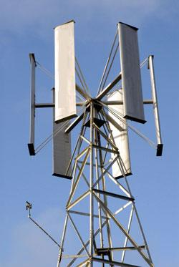
Vertical Axis Wing Generators can lower your energy bills and pay for them selves quickly when installed by MKG Wind power. SEE Below



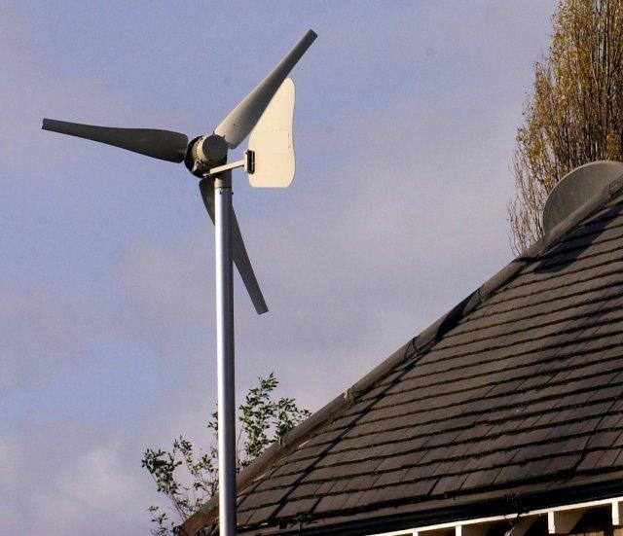

Mid Kent Generators offer a wide range of wind powered solutions for domestic and commercial applications.

Our domestic turbines power range starts at 500Watts enabling a cheaper way of lowering your carbon footprint. At mid Kent Generators we believe everyone can have the opportunity to make a difference.

Our Wind Turbines start at incredible low prices including the inverter and control system. When installed by us we offer a discounted price to allow Green energy to benefit you homes and the future.

Short of space no problem we try to offer the best solution to benefit both you and the environment no matter how small. Start making a difference today with Mid Kent Generators

Wind Power UPS

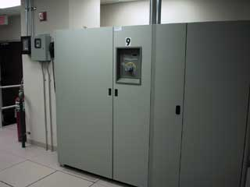

As you know Uninterruptible power systems require a power source to charge them, here at mid Kent generators we have been experimenting with wind generators to charge small systems when power cuts are less frequent.

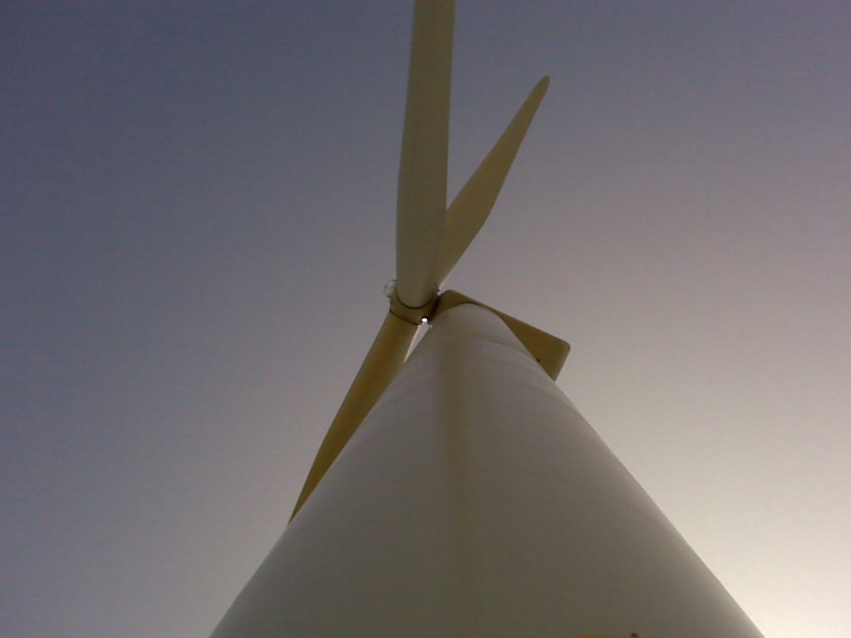
Nordex
Turbine shown above Located at New Romney Wind Farm Kent on the day of opening 2009
Mid Kent Generators also offer Larger Wind Turbine capable of producing 2.4MW each and also offer installation services with maintenance schedules.

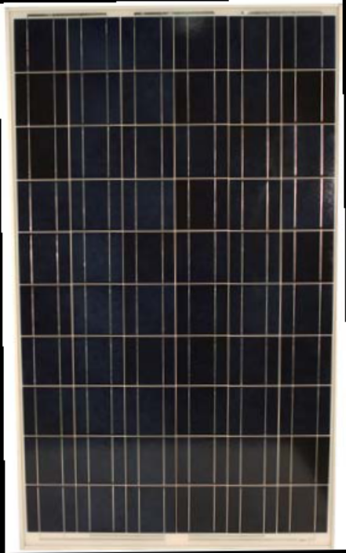

Solar power available call now all enquiries

Our solar panel ranges start from 40watts upwards and have been proven to be a growing contributor in the green energy market.

Vertical Axis Wind Turbines

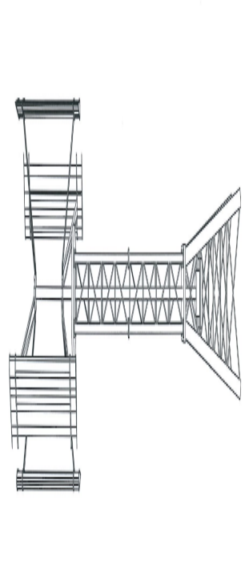
Small and Larger Vertical access Wind Turbine are available on request

Available up to 20KW and can offer a full installation service

Contact us know for further information

